
SolOhm
Lowering Panel Testing Costs

Montrose, Colorado
Craig Hollabaugh
holla@solohm.com
970 316 3165
https://github.com/holla2040/solohm

SolOhm - Monitor

Lowering Panel Testing Costs
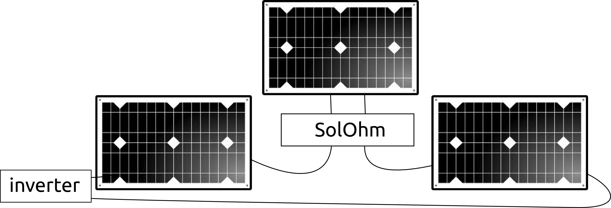
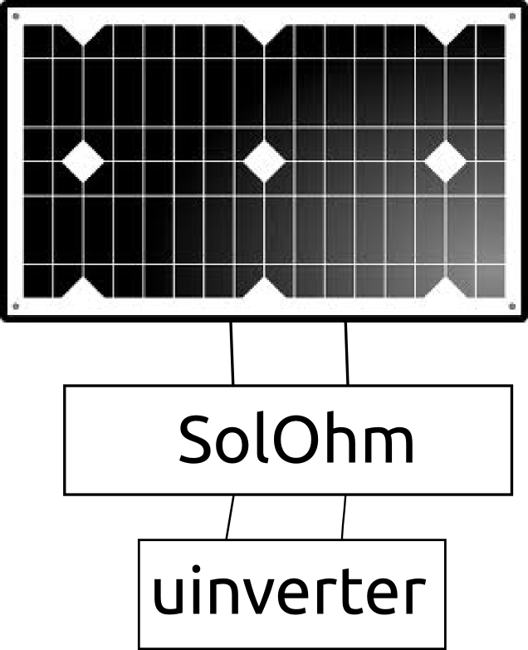

SolOhm - Monitor
Ammeter, 10A range, 1.2mOhm sense resistor
Voltmeter, 50VDC range
Temperature Sensors, multiple, daisy-chained, digital +/- 0.5C -10 to +85C, DS18B20
Wireless Status Broadcast, WiFi
Calibration, requires external power supply, ammeter and voltmeter
Panel Powered
Plastic Enclosure, 3”x3”x2”, IP54
String inverter or micro-inverter operation
HTTP REST and UDP broadcast communications
Open Source hardware and software
Over the air firmware update
Arduino development environment, experienced firmware developer not required

SolOhm - Sweep

Lowering Panel Testing Costs

SolOhm - Sweep
Ammeter, 10A range, 1.2mOhm sense resistor
Voltmeter, 50VDC range
Temperature Sensors, multiple, daisy-chained, digital +/- 0.5C -10 to +85C, DS18B20
Wireless Status Broadcast, WiFi
Calibration, requires external power supply, ammeter and voltmeter
Panel Powered
Plastic Enclosure, 3”x3”x3”, IP54
String inverter or micro-inverter operation
HTTP REST and UDP broadcast communications
Open Source hardware and software
Over the air firmware update
Arduino development environment, experienced firmware developer not required

IV Curve Sweep, 300W range, less than 1 second acquisition time
Internal string disconnect circuit
24-hour operation using LiPo battery

SolOhm - Load

Lowering Panel Testing Costs

SolOhm - Load
Ammeter, 10A range, 1.2mOhm sense resistor
Voltmeter, 50VDC range
Temperature Sensors, multiple, daisy-chained, digital +/- 0.5C -10 to +85C, DS18B20
Wireless Status Broadcast, WiFi
Calibration, requires external power supply, ammeter and voltmeter
Panel Powered
Enclosure, 8”x8”x5”, IP54
String inverter or micro-inverter operation
HTTP REST and UDP broadcast communications
Open Source hardware and software
Over the air firmware update
Arduino development environment, experienced firmware developer not required

IV Curve Sweep, 300W range, less than 1 second acquisition time
Internal string disconnect circuit
24-hour operation using LiPo battery

MPPT
Fan-cooled heat sink
TEC cooled analog circuitry
MPPT, CV, CC modes
Real time clock for timestamp generation
uSD card for disconnected data logging
OLED Display
GSM/GPRS option

SolOhm - µInverter

Lowering Panel Testing Costs

SolOhm - µInverter
Ammeter, 10A range, 1.2mOhm sense resistor
Voltmeter, 50VDC range
Temperature Sensors, multiple, daisy-chained, digital +/- 0.5C -10 to +85C, DS18B20
Wireless Status Broadcast, WiFi
Calibration, requires external power supply, ammeter and voltmeter
Panel Powered
Enclosure, 8”x8”x5”, IP54
HTTP REST and UDP broadcast communications
Open Source hardware and software
Over the air firmware update
Arduino development environment, experienced firmware developer not required

IV Curve Sweep, 300W range, less than 1 second acquisition time
24-hour operation using LiPo battery

MPPT
Fan-cooled heat sink
TEC cooled analog circuitry
MPPT, CV, CC modes
Real time clock for timestamp generation
uSD card for disconnected data logging
OLED Display
GSM/GPRS option

Grid tie
High-precision multiple PWM/ADC control loops
Precision AC measurements, line frequency, voltage, current
On-board DSP

